1. Transfer 1 ether as wei

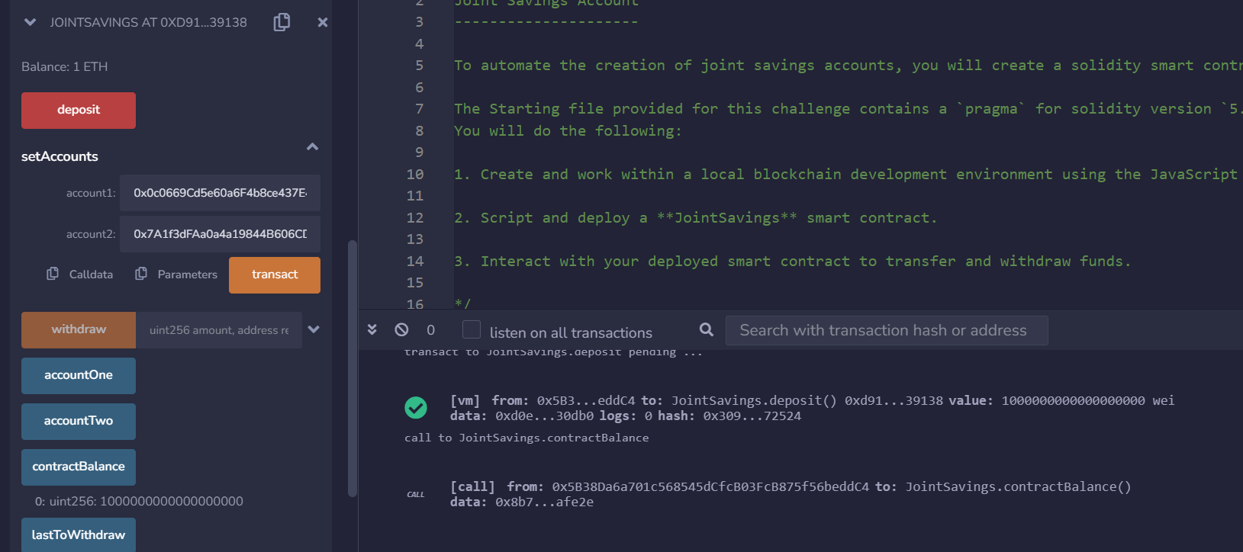

1. Transfer 10 ether as Wei

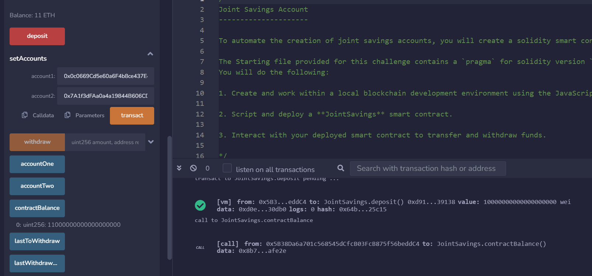

1. Transfer 5 ether

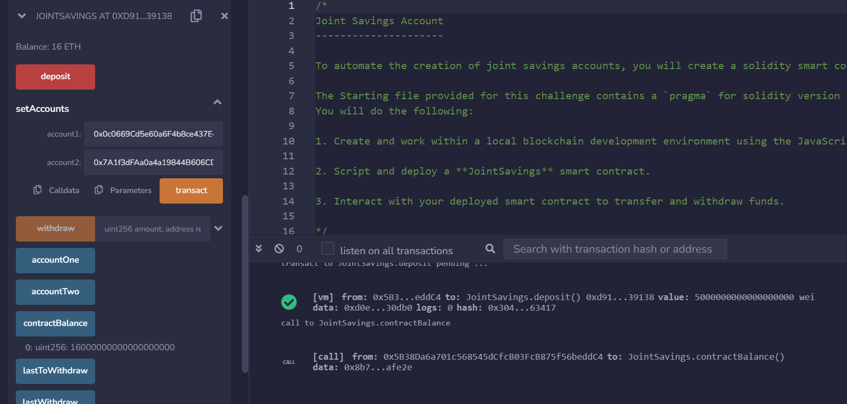

1. With 5 into acct 1 and 10 in acct 2

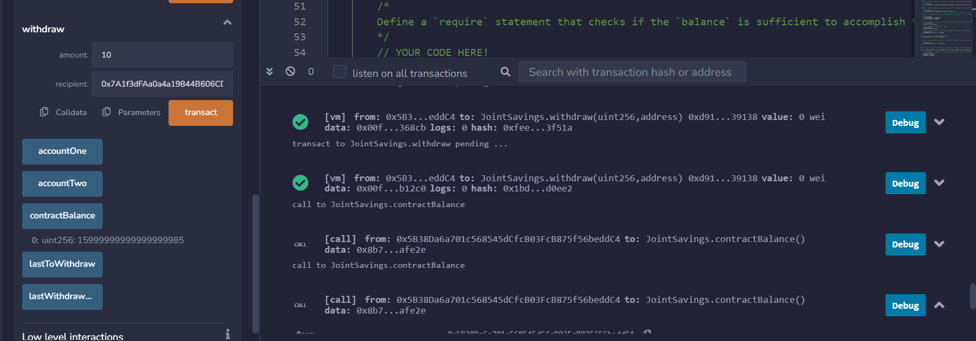

1. Use last to withdraw and Last withdrawn amount

